Experiment 8

1. Aim:
To design and implement report scheduling, automation, and alert mechanisms using Microsoft Power BI and develop strategies for automated report delivery, monitoring, and business performance tracking.

2. Tools / Software Required:
- Microsoft Power BI Desktop
- Microsoft Power BI Service
- Global Superstore Dataset.xlsx
- Microsoft Excel

4. Theory:
Business Intelligence systems must deliver information to stakeholders at the right time. Scheduled reporting, automated distribution, and KPI alerts help organizations monitor performance and take timely actions. Power BI Service supports subscriptions, scheduled refreshes, report sharing, and data-driven alerts.

Business Scenario
Global Superstore management requires automated delivery of reports and timely notifications whenever business performance changes significantly. Students will act as BI Operations Engineers and design a reporting automation strategy.
5. Procedure:

Part A – Create Scheduled Reporting Plan in Power BI

Step 1: Open Power BI Desktop
- Open your existing Global Superstore .pbix report.
- Go to the Home tab.
- Click Enter Data.

Step 2: Enter the scheduling table
A Create Table window will appear.
Enter these column names and values:

Report Name | Frequency | Intended Users | Delivery Time
Daily Sales Report | Daily | Sales Manager | 9:00 AM
Weekly Profit Report | Every Monday | Finance Manager | 10:00 AM
Monthly Executive Dashboard | Monthly | Senior Management | 11:00 AM
- Rename the table to Scheduling_Plan.
- Click Load.
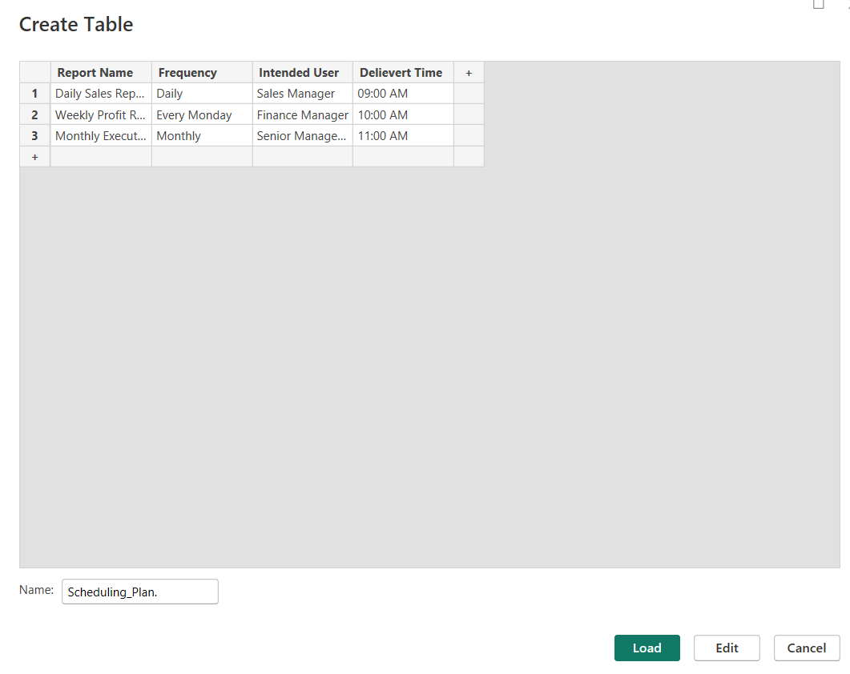

Step 3: Create the Report Distribution Matrix
- Go to Home → Enter Data again.
- Enter the following:
User Group | Report Name | Frequency | Delivery Method
Sales Team | Daily Sales Report | Daily | Email / PDF
Finance Team | Weekly Profit Report | Weekly | Email / PDF
Regional Managers | Regional Sales Report | Weekly | Shared Workspace
Senior Management | Executive Dashboard | Monthly | Power BI Dashboard
Operations Team | KPI Monitoring Report | Daily | Email
- Name the table Distribution_Matrix.
- Click Load.
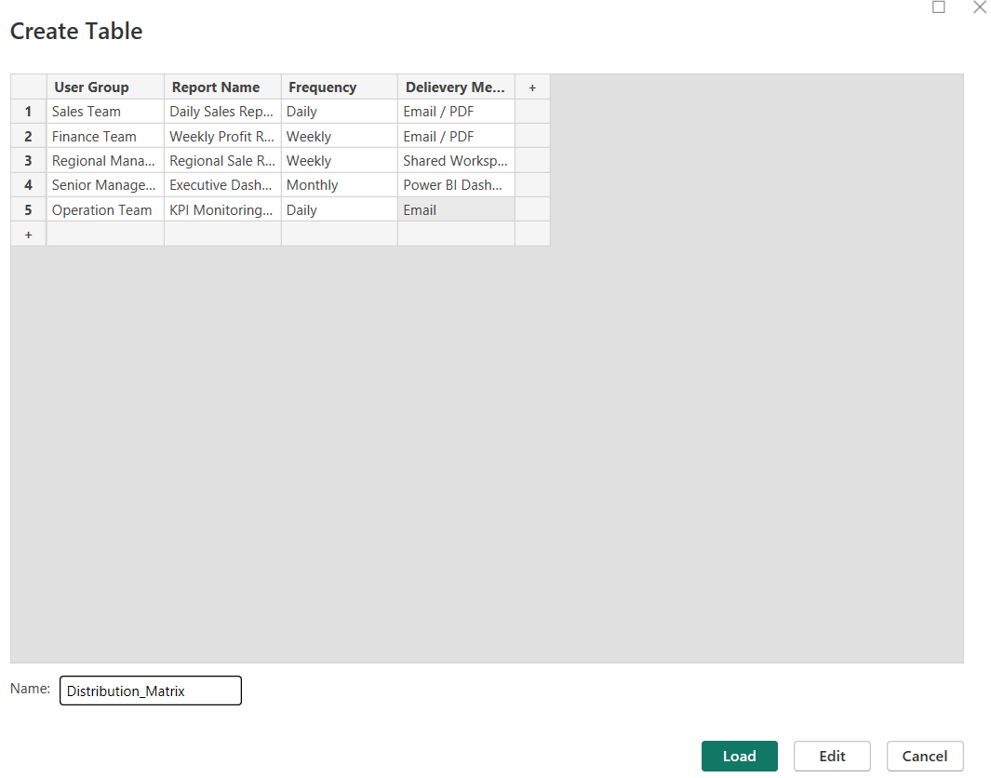

Step 4: Create KPI Alert Configuration
- Again select Home → Enter Data.
- Enter:
KPI | Alert Condition | Recipient | Recommended Action
Profit Margin | Below 10% | Finance Manager | Review expenses and pricing
Sales | Decline greater than 15% | Sales Manager | Investigate sales decline
Returns | Increase greater than 20% | Operations Manager | Investigate product quality
- Name the table KPI_Alert_Config.
- Click Load.
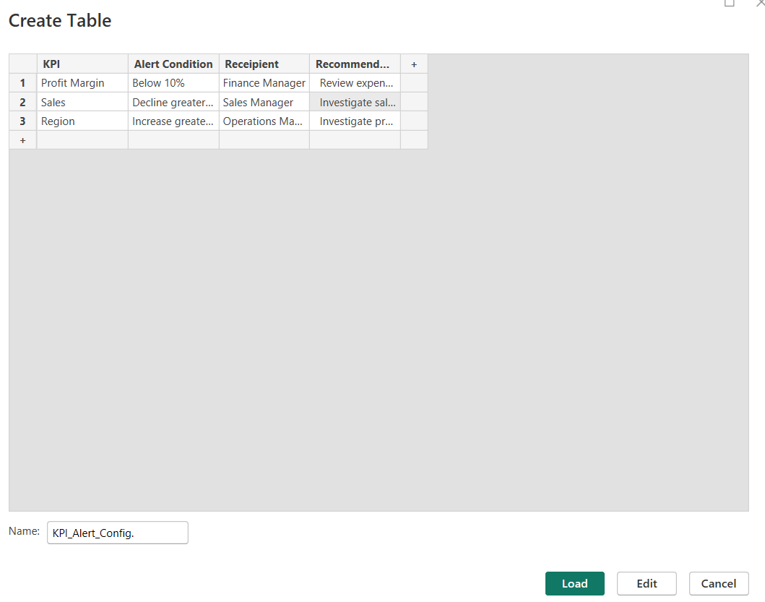

Part C: KPI Alert Configuration

Step 1: Create KPI measures
Go to Modeling → New Measure.

- Total Sales = SUM(Orders[Sales])
- Total Profit = SUM(Orders[Profit])
- Profit Margin = DIVIDE([Total Profit], [Total Sales], 0)
- Total Orders = DISTINCTCOUNT(Orders[Order ID])
Step 2: Create Profit Margin Card
- Select Card visual.
- Drag Profit Margin into the card.
- Format as Percentage.
- Set title: Profit Margin KPI.
Step 3: Create Alert Status Measure
Profit Margin Alert =
IF(
[Profit Margin] < 0.10,
"ALERT: Below 10%",
"NORMAL"
)
Add this measure to another Card visual.

Part D: Monitoring Scenario Analysis
Step 4: Create Regional Profitability Chart
- Select Clustered Bar Chart.
- Y-axis → Region.
- X-axis → Profit (Sum).
- Sort by Sum of Profit → Ascending.
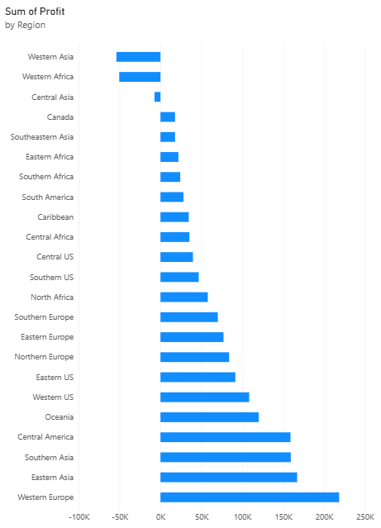
Step 5: Create Monitoring Scenario Table
Go to Home → Enter Data.
Business Problem | Alert Trigger | Responsible Person | Corrective Action
Low Profitability | Profit Margin below 10% | Finance Manager | Review expenses
Sales Decline | Sales decline above 15% | Sales Manager | Improve sales strategies
Increasing Returns | Returns increase above 20% | Operations Manager | Investigate product quality
1. Name: Monitoring_Analysis
2. Click Load
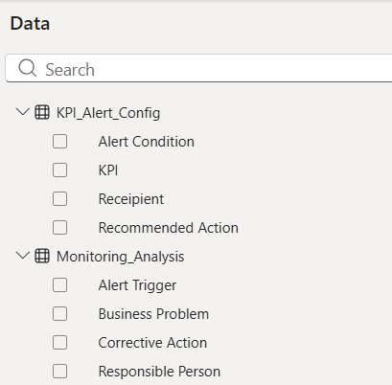

6. Result:
Report scheduling, automation, and alert strategies were successfully designed. Automated reporting plans and monitoring mechanisms were developed to support business operations.
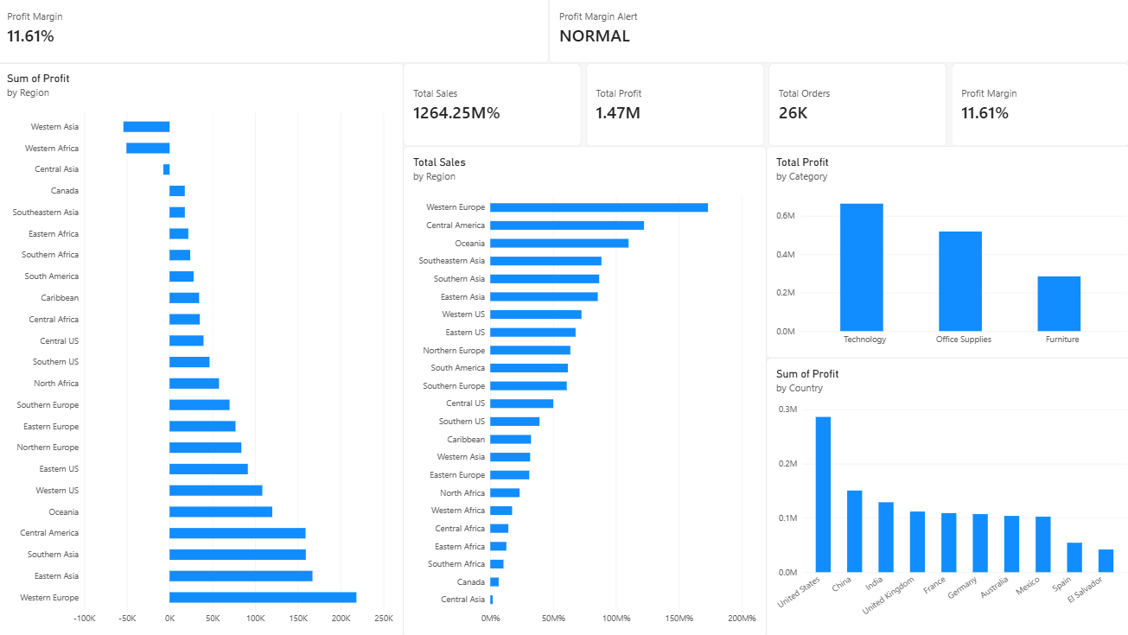

7. Learning Outcomes
• Apply report scheduling concepts in BI systems.
• Design automated report distribution strategies.
• Analyze KPI monitoring requirements.
• Evaluate alert mechanisms for business decision support.
• Develop recommendations for BI operations.

